North Lincolnshire Council
Daily Event Analysis
5th November 2010

Overview
The Low Santon TEOM measured a daily mean PM₁₀ concentration of 74µg/m³ on Friday the 5th November 2010 exceeding the allowed 50µg/m³ as a daily mean. A check of the data has revealed that concentrations of PM₁₀ began to increase at 08:00 and fell at 15:15. During this 7 hour period concentrations at the Low Santon TEOM measured a mean concentration of 134µg/m³. The Dawes Lane Coke Oven (DLCO) Osiris measured a daily mean concentration of 54µg/m³. The Osiris measured a mean concentration of 60µg/m³ during the 7 hour focus period.

Met Conditions
Consistent SW winds were observed throughout the day. The wind during the 7 hour period of focus ranged between 195° and 259°. Wind speeds were relatively low averaging at 2.6 m/s. The period of focus averaged at 2.5m/s. The highest wind speed in this period was 3.4m/s in which the concentration of PM₁₀ reached 207µg/m³. Light rain was observed early evening.

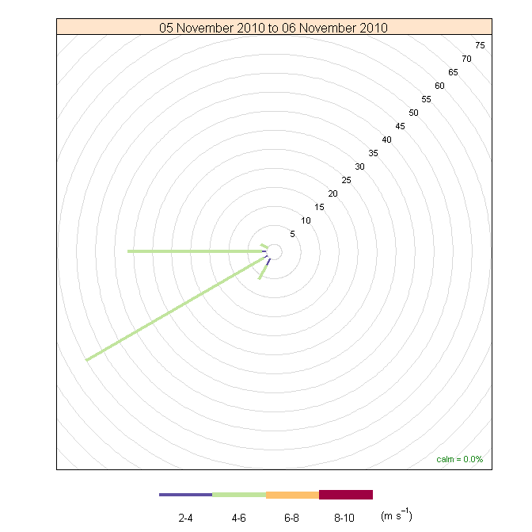

Episode Wind Range

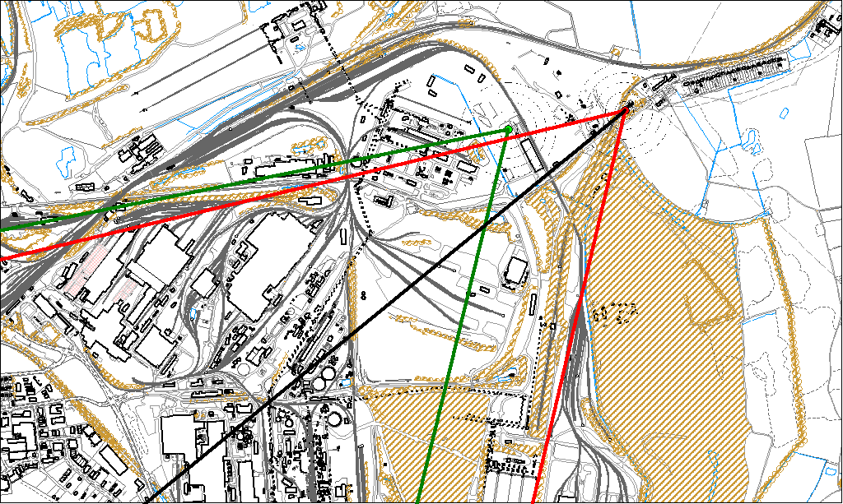

Potential Sources
The above map shows the Low Santon TEOM (indicated by the red lines) and the DLCO Osiris (indicated by the green). The black line within the red shows the wind direction of the highest concentration recorded during the 7 hour period of focus.

As the Low Santon TEOM measured consistently higher concentrations during this period, it is likely that the TEOM was affected by a different source to the DLCO Osiris. Therefore, areas in which the red and green lines intersect are unlikely to be the location of the problem.
The likely areas include;

- Tarmac
- The Redbourn Steel Stocking Area
- The Intermediate Site
- Slag Haul Road
- Ore Beds

The black line indicates the highest measured concentration during this period. This runs through the Redbourn Steel Stocking Area.

6th November 2006

There was an exceedence at the East Common Lane site on Saturday 6th November. The daily mean PM₁₀ concentration of 52µg/m³ was measured exceeding the allowed 50µg/m³ as a daily mean.

The wind range for this exceedence ranged between 348° and 9°. The elevated levels of PM₁₀ highlighted on the graph occur between 18:00 and 00:00. Due to this weekend being Bonfire Night and the timing of these elevated levels it is likely this exceedence may have been caused by domestic bonfires and fireworks.

